STAFF REPORT TO THE DESIGN REVIEW COMMITTEE (DRC)

Permit Type: Design Review
File No. Z0516-25
Applicant’s Proposal: The proposal is for two new buildings to house adult drug and alcohol treatment services, and associated transitional housing and site development. Building 1 is a two-story, 27,550 square foot building that will include 16 withdrawal management beds arranged for 24/7 nurse supervision. Patient stays in withdrawal management will last approximately one week. Building 1 also includes 24 beds for residential treatment, arranged in sleeping rooms of two patients per room. Spaces for group meetings, individual counseling, dining, and recreation are also included, and residential treatment stays last approximately three months. Administrative offices associated with treatment services will also be in Building 1. An enclosed private courtyard will be accessible from Building 1.
Building 2 is two stories and 17,175 square feet. Building 2 includes an outpatient treatment clinic with group meeting rooms, rooms for individual counseling, and a multipurpose room for larger gatherings. Building 2 includes 36 beds for transitional housing arranged into sleeping rooms of two patients per room. Patients will share restrooms, kitchen, and lounge space. Patients will live in the building for six months to a year while accessing intensive outpatient services on site. An enclosed private courtyard will be accessible from Building 2.
Initial Design Review Committee Meeting Date: March 10, 2026
Subsequent Design Review Committee Meeting Date: March 31, 2026
Date of this Report: March 25, 2026

Issued By: Melissa Lord, Senior Planner, MLord@clackamas.us, 503-742-4504
Applicant: Fora Health Treatment and Recovery Center
Owner of Property: Clackamas County
Zoning: General Commercial (C-3) and Open Space Management (OSM) Districts
Assessor’s Map & Tax Lot(s): T2S R2E Section 09BD Tax Lots 4900
Site Address: 15301 SE 92nd Ave, Clackamas, OR 97015
Location Map

Site Plan (overall)
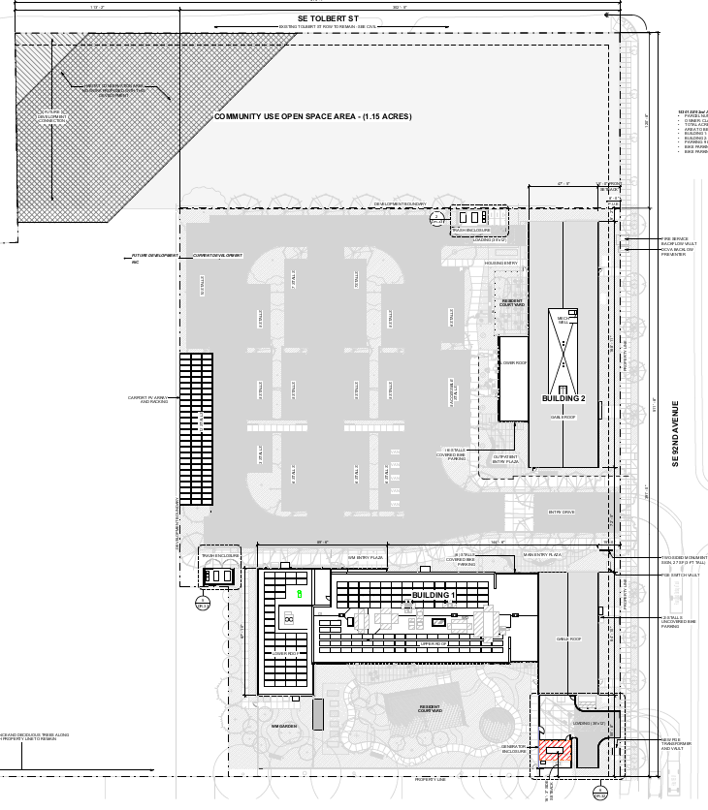
Overall Materials Plan
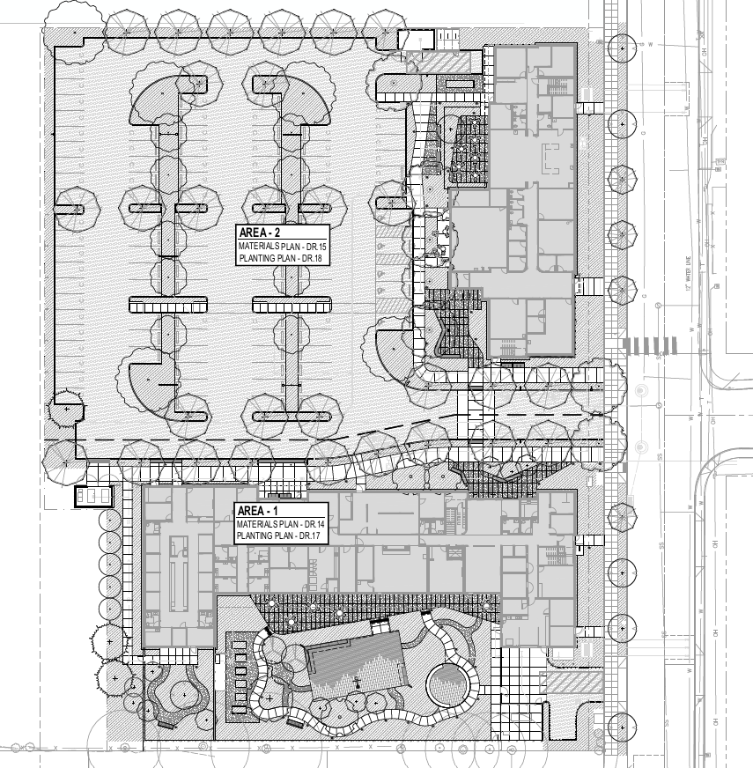

Materials Plan (South/Building 1)
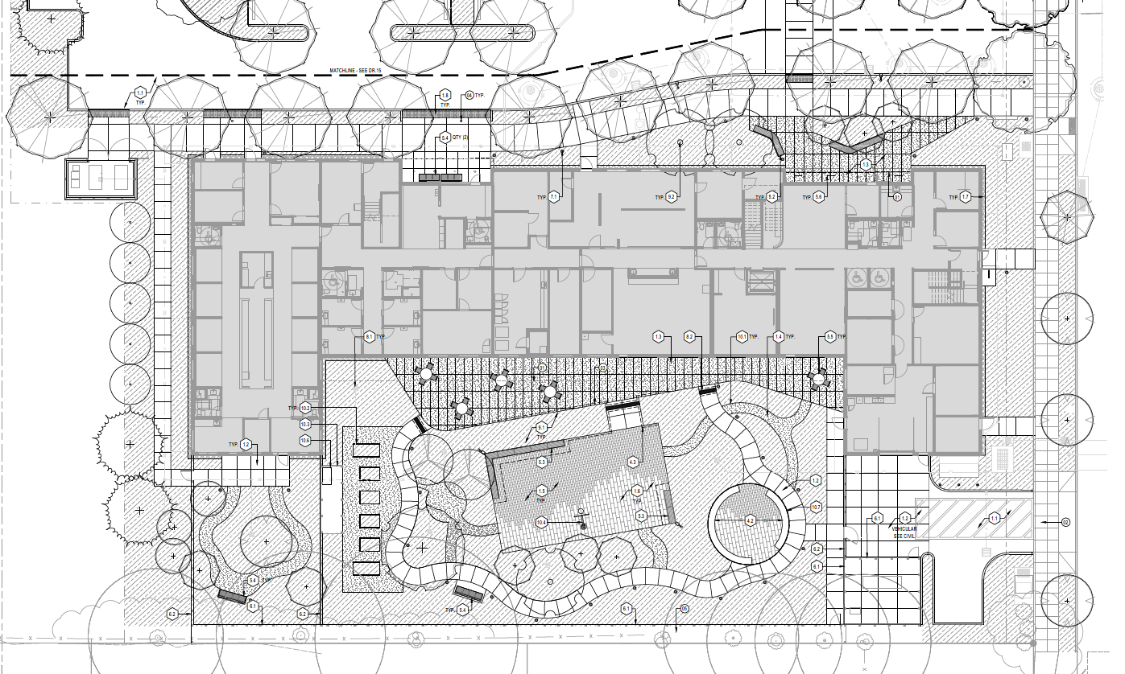

Materials Plan (North/Building 2)
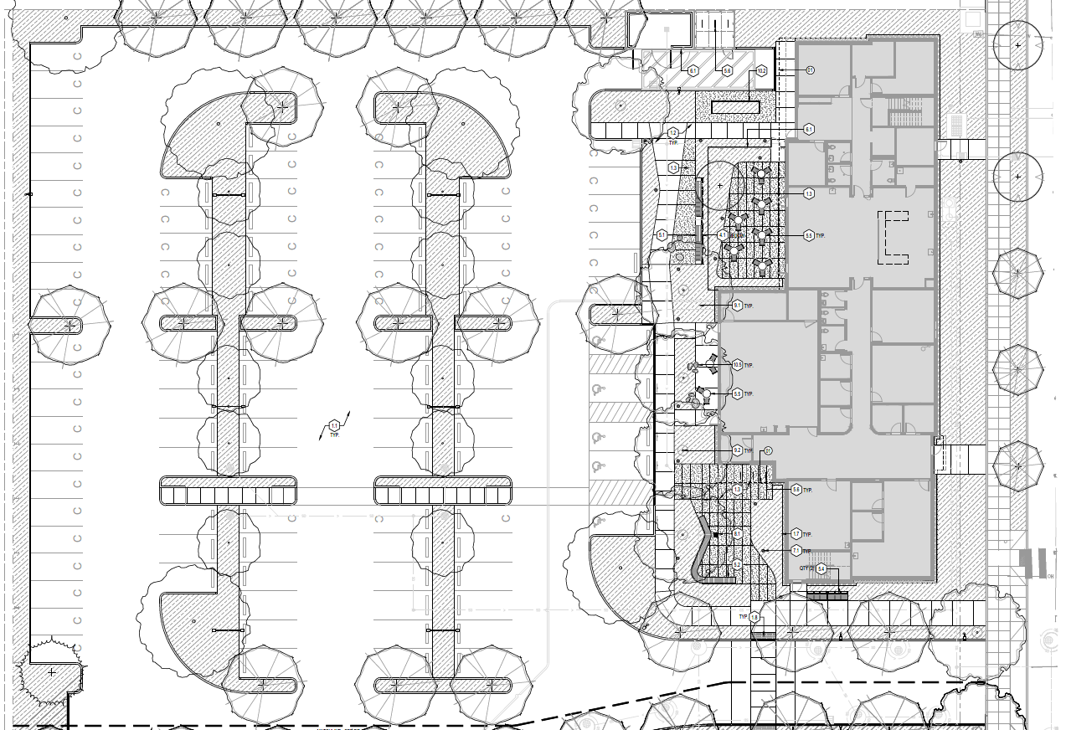

RECOMMENDED CONDITIONS OF APPROVAL
The conditions listed are necessary to ensure that approval criteria for this land use permit are satisfied. Where a condition relates to a specific approval criterion, the code citation for that criterion follows in parentheses. At all times, the use shall be sited and conducted in compliance with these conditions of approval.
- The surfaces of metal exterior building materials that are subject to rust or corrosion shall be coated to inhibit such rust and corrosion, and the surfaces of metal exterior building materials with rust or corrosion shall be stabilized and coated to inhibit future rust and corrosion [1005.03(E)]
- Entrance lighting may not exceed a height of 12 feet and must be directed downward. [1005.04(A)]
- The trash enclosures must have a level Portland Cement concrete pad, a minimum four inches thick. The pad shall be designed to discharge surface water runoff to avoid ponding. [1021.03]
- Prior to issuance of a building permit or grading permit, a Construction Management Plan, consistent with Subsection 706.08, shall be required prior to development. The Construction Management Plan shall be reviewed in conjunction with review of a building or grading permit
- Prior to issuance of a building permit for Building 1, updated plans must be submitted to show a sound barrier on the south side of the generator. The sound barrier shall be constructed of a minimum of two layers of 3/4-inch plywood on a wood frame, if no holes or gaps are found within the barrier. Where visible from the public right of way, the sound barrier shall look the same as the rest of the approved fence which is a 5/4 western cedar slats and stained to match.
- Prior to certificate of occupancy, all landscaping shall be installed in accordance with the approved plans. For the purposes of obtaining a certificate of occupancy, landscaping installation can be parsed out into two parts that correlate with the landscaping associated with each building as follows:
  - To obtain a certificate of occupancy on Building 1, all landscaping shown in “Planting Area 1” and the parking lot shall be installed; this area generally includes the plantings on the south of the driveway, but is specifically identified on Sheet DR.17.
  - To obtain a certificate of occupancy on Building 2, all landscaping shown in “Planting Area 2” and the parking lot shall be installed; this area generally includes the plantings on the north of the driveway and in the parking lot, but is specifically identified on Sheet DR.18.
  - Parking lot landscaping is required prior to issuance of any certificate of occupancy. Parking lot landscaping is identified as the perimeter, swale, and interior landscaping, and the landscaping on the north side of the driveway between the driveway and the walkway. This parking lot area is identified in the image below; the red line delineates the parking lot landscaping from the landscaping associated with Building 2.
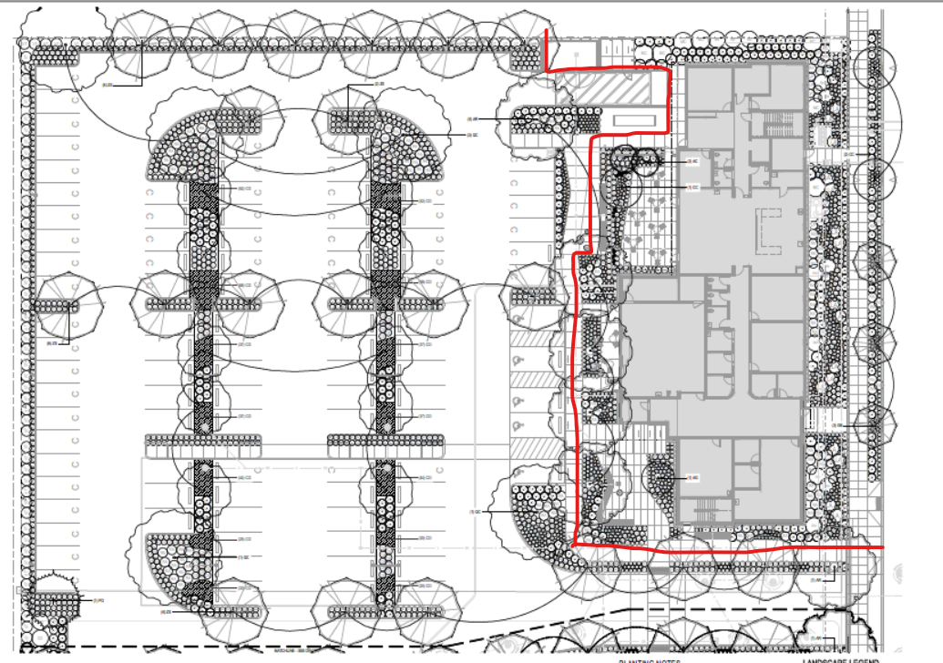
- Prior to certificate of occupancy, the applicant shall:
  - Remove all English holly from the site [1009.01(C)].
  - Demonstrate that a landscaping strip a minimum of five feet in width along the southern property boundary a distance of 615 feet from the eastern property line, that includes the following three items [1009.04(E)]:
    - A sight-obscuring fence a minimum of six feet in height. The wall or fence is to be placed along the interior side of the landscaping strip;
    - Evergreen vines, evergreen trees, or evergreen shrubs, any of which shall be spaced not more than five feet apart; and
    - Low-growing evergreen shrubs and evergreen ground cover covering the balance of the area.
- When planted, deciduous trees shall be fully branched, have a minimum caliper of two inches, and have a minimum height of eight feet. [1009.10]
- When planted, evergreen trees shall be fully branched, have a minimum height of eight feet, and have only one leader. [1009.10]
- Shrubs shall be supplied in minimum one-gallon containers or eight-inch burlap balls with a minimum spread of 12 inches. [1009.10]
- Ground cover shall be planted a maximum of 30 inches on center with a maximum of 30 inches between rows. Rows of plants shall be staggered. Ground cover shall be supplied in minimum four-inch containers, except that the minimum shall be reduced to two and one-quarter inches or equivalent if the ground cover is planted a minimum of 18 inches on center. [1009.10]
- Landscaping materials shall be guaranteed for a period of one year from the date of installation. Prior to certificate of occupancy, the developer shall either submit a signed maintenance contract for the one-year period or provide a performance surety pursuant to Section 1311, Completion of Improvements, Sureties, and Maintenance, covering the landscape maintenance costs for the one-year period [1009.10(F)]
- Prior to certificate of occupancy for Building 1, all sleeping unit windows on the southern façade of Building 1 shall have interior blackout window shades installed to prevent excessive summer heat gain. [1005.03(H)]
- The waste/recycling containers shall be located on a level Portland Cement concrete pad, a minimum four inches thick. [1021.03(A)]
- The walkway through the parking lot shall be at least five feet wide to prevent parked vehicles or opening doors from obstructing the walkway. [1005.02(D)(5)(e)]
- Prior to certificate of occupancy, the applicant shall:
  - Obtain a Development Permit for public improvements along SE 92nd Ave and onsite pedestrian, parking, access and circulation improvements. Permitting fees are determined by the current fee structure at the time of the permit application.
  - Meet the requirements for Substantial Completion set forth within Section 190 of the Clackamas County Roadway Standards.
  - Dedicate a minimum eight-foot wide public sidewalk, sign and utility easement along SE Tolber St and SE 92nd Ave.
- Prior to development permit issuance, the applicant shall:
  - Enter into a Developer – Engineer Agreement for primary inspection services per section 180 of the Clackamas County Roadway Standards.
  - Submit a performance surety in the amount of 125% of the approved cost estimate for work within the County right-of-way or enter into an IGA with Clackamas County DTD for performance and activities.
  - The applicant shall submit approvable plans showing minimum half-street improvements per standard drawing C110:
    - Minimum 16-feet of pavement meeting structural requirement for urban local street serving commercial
    - Six-inch standard curb or curb and gutter with running slope is less than 1%
    - Five-foot wide planter strip with street trees and street lighting
    - Six-foot wide ADA compliant sidewalk
    - Minimum 28-foot wide commercial driveway entrances per standard drawing D650 at parking access and loading zone.
    - Dual ADA ramps per ODOT RD 912 at the intersection of SE Tolbert St and SE 92nd Ave
    - Provide ADA compliant ADA end of walk ramp at the southern terminus per ODOT 952 with OM4-4 signage.
    - Provide onsite commercial vehicle maneuvering templates to ensure all delivery and solid waste trucks access County roadway in a forward motion.
    - All onsite parking and maneuvering for passenger vehicles shall meet dimensions per Roadway Standards standard drawing P100/P200.
    - Structural section of onsite parking, access and circulation areas shall meet minimum requirements of standard drawing R100.
    - Provide onsite pedestrian access from the public sidewalk to the public entrance and illuminated pedestrian routed between buildings.
    - The applicant shall display the minimum number of illuminated bicycle parking on the approved plans with a minimum of 75% being within 50-feet of the public entrance and 50% being covered.
    - Provide separate striping and signage plan showing proposed and required improvements.
  - Pavement and utility trench restoration shall meet standard drawings U200, U280 and U290
  - The applicant shall provide and maintain minimum intersection sight distances along SE 92nd Ave. Intersection sight distance shall restrict plantings at maturity, retaining wall, embankments, trees, fences or any other objects that obstruct vehicular sight distance. Minimum required intersection sight distance is 280-feet along SE 92nd Ave.
  - Provide written approval from:
    - Clackamas River Water for public water distribution and connection
    - Water Environmental Services for stormwater and sanitary improvements
    - Clackamas County Sustainability for solid waste
    - Clackamas Fire for emergency access, circulation and fire suppression
- Prior to final inspection, the applicant shall:
  - Meet the minimum requirements of Section 190 for Substantial Completion including fire, life and safety improvements.
  - Submit warranty surety in the amount of 25% of approved cost estimate or enter into IGA with Clackamas County DTD for warranty and activities.
- Street lighting shall be installed pursuant to the requirements of Clackamas County Service District No. 5 and the electric company serving the development. [1006.02]
- Areas outside Clackamas County Service District No. 5 shall annex to the district through petition to the district. [1006.02]
APPLICABLE APPROVAL CRITERIA
This application is subject to Clackamas County Zoning and Development Ordinance (ZDO) Section(s) 202, 510, 706, 903, 1000-series, 1102, and 1307.
PUBLIC AND AGENCY COMMENTS
Notice was sent to applicable agencies and owners of property within 300 feet. Comments received relating to the applicable approval criteria listed above are addressed in the Findings Section. At the time of this report, comments have been received from Clackamas Water Environment Services (WES), Clackamas River Water, Clackamas Fire District #1, Clackamas Solid Waste and Sustainability, Clackamas Development Engineering. No public comments have been received.
FINDINGS
The findings below identify the standards and criteria that are relevant to this report, state the facts relied upon in writing findings, and explain the justification for the finding.
- Background/Overview of Applicant’s Proposal:
Demolition of existing building and new construction of two buildings with site improvements. Building 1 is an approximately 28,000 square foot treatment facility. Building 2 is an approximately 17,000 square foot transitional housing building with outpatient services.
The property was most recently zoned High Density Residential (HDR) and Open Space Management (OSM) until a Comprehensive Plan Amendment and a Zone Change application were approved to its current General Commercial (C-3) and OSM zoning designations (reference land use application Z0169-25 and Z0170-25). The development proposed in this land use application is taking place exclusively on the C-3 portion of the site.
A pre-application conference was held on October 30, 2025 to discuss the preliminary plan. The Design Review Committee (DRC) reviewed this application on March 10, 2026 and did not move to make a recommendation. The DRC will review the updated application again on March 31, 2026.
The subject property was recently approved for a Comprehensive Plan Amendment Zone Change which established the C-3 zoning designation and changed the extent of the OSM zoning designation on site to its current configuration. Relevant conditions of approval from the associated land use applications, Z0169-25 and Z0170-25 include:
Uses permitted within the C-3 designation on the subject property are limited to the following:
  - A. Dwellings:
  - Multifamily, quadplex, triplex, duplex, or townhouse units: maximum 150 units
  - Transitional housing/single room occupancy units: maximum 80 beds

  - B. Residential treatment facility:
  - Medical withdrawal management (detox): Maximum 16 beds
  - Substance use disorder (SUD) residential treatment services: Maximum 50 beds

  - C. Medical office and outpatient clinics: Maximum 10,000 square feet

  - D. Customarily permitted accessory uses, including but not limited to offices and childcare facilities, provided the childcare facility is not open to the public.
These conditions of approval are referenced within this report further below because they dictate the level of development allowed.
- Oregon House Bill 2005 (HB2005):
Oregon House Bill 2005 (HB2005) from the 2025 legislative session took effect July 24, 2025; Section 59 provides facility siting standards for a residential treatment facility. The proposed use of Building 1 is a residential treatment facility, as defined in ORS 443.400.
Section 59 (1) Within an urban growth boundary, a local government shall allow a residential treatment facility or residential treatment home, as those terms are defined in ORS 443.400, without requiring a plan amendment, zone change or conditional use permit for property that is:
(a) Owned by a public body, as defined in ORS 174.109; or
(b) Zoned for:
(A) Residential uses;
(B) Commercial uses;
(C) Employment uses;
(D) Public lands, not including park land; or
(E) Industrial uses, provided that if the property is:
(i) Publicly owned or owned by a public benefit corporation as defined in ORS 65.001;
(ii) Within 250 feet of lands zoned for residential use; and
(iii) Not specifically designated for heavy industrial uses.
Finding: The subject property is located within the Portland Metropolitan Urban Growth Boundary. The applicant has not been asked to submit a plan amendment, zone change or conditional use permit for their proposal to establish a residential treatment facility. The subject property is in the C-3 zoning district which is a commercial zone that allows commercial uses. The subject property is also owned by Clackamas County, a public body. Therefore, these criteria are met.

Section 59 (2) This section does not apply on land where the local government determines that:
(a) The facility cannot be adequately served by water, sewer, storm water drainage or streets, or will not be adequately served at the time that development on the property is complete; or
(b) The development of the property is constrained by land use regulations based on statewide land use planning goals relating to:
(A) Natural disasters and hazards; or
(B) Natural resources, including air, water, land or natural areas, but not including open spaces or historic resources.
Finding: The subject property is served by public water, sewer and stormwater. The applicant submitted signed Statement of Feasibility forms from Clackamas Water Environment Services, the sanitary sewer and surface water management authority, and from Clackamas River Water, the water service provider.
The signed forms confirm that the facility can be adequately served by water, sewer, storm water drainage or streets, or will not be adequately served at the time that development on the property is complete.
The property is not located within a special flood hazard areas identified by the Federal Insurance Administration in a scientific and engineering report entitled, “The Flood Insurance Study for Clackamas County, Oregon & Incorporated Areas,” dated January 18, 2019, with accompanying Flood Insurance Rate Maps. The property does not have any mass movement hazards or soil hazards identified on the State Department of Geology and Mineral Industries Bulletin 99 and accompanying maps. The subject property is served by the Clackamas Fire District #1 and is located within an urban area, developed with urban services. The property is not in a wildland urban interface and as a result, the risk of wildfire is inherently low.
County staff reviewed this property and have identified areas mapped Title 13 Habitat Conservation Area located predominantly within the OSM-zoned portion of the site and a small amount within the C-3-zoned portion of the site. However, the applicants site plan demonstrates that the mapped Habitat Conservation Area will not be impacted by the proposed development.
The property is not within the river and stream conservation area. The property is also not within a ground water limited area. The property is not on lands or water within the Willamette River Greenway and not identified on Comprehensive Plan Map 3-01e, Willamette River Greenway Design Plan. The Mineral and Aggregate Overlay District carries out the decisions and policies of the Comprehensive Plan for significant mineral and aggregate resources. The overlay is not applied to the subject property and compliance with the associated ZDO Section 708 is not applicable. The Sensitive Bird Habitat District is an overlay district that consists of sensitive bird habitat areas as identified in the Comprehensive Plan policies and Sensitive Bird Inventory completed pursuant to the Goal 5 and Oregon Administrative Rules 660, Division 16 provisions. There are no sensitive habitat areas to be protected, pursuant to ZDO Section 710, on the subject property.
In conclusion, staff finds that the development is not constrained by natural resource areas, including water, air, land or natural areas. Therefore, these criteria are met.

Section 59 (3) This section does not trigger any requirement that a local government consider or update an analysis as required by a statewide land use planning goal relating to economic development.
Finding: This criterion is informational and does not require action by the County or applicant to comply. Planning staff acknowledges this criterion and is not proceeding with any analysis relating to a statewide land use planning goal relating to economic development. This criterion is met.

Section 59 (4) A decision made under this section is not a land use decision as defined in ORS 197.015 and is not subject to the jurisdiction of the Land Use Board of Appeals. A decision under this section may only be appealed by writ of review under ORS 34.010 to 34.100.
Finding: This is not an approval criterion; rather, it dictates the process for a state-level appeal of the county’s final decision on this permit. If the staff decision is appealed to the Land Use Hearings Officer, the Hearings Officer will issue the county’s final decision, and any appeal of that decision would be subject to this provision.

Section 59 (5) A local government shall issue a final decision under this section within 120 days after a completed application is filed with the local government.
Finding: The application was filed with the County on December 22, 2025. The application was deemed complete on January 28, 2026 and the decision is forthcoming. 120 days from when the application was deemed complete is May 28, 2026 and so a decision must be issued by then to be compliant with this standard.
- ZDO Section 510, General Commercial (C-3) District
510.03 Uses Permitted: Uses permitted in the C-3 zoning district are listed in Table 510-1.
Finding: The subject property is located in the OSM and C-3 zoning district. The application does not propose any uses in the OSM portion of the site. The proposed uses in the C-3 portion of the site is Building 1 with “a treatment facility (withdrawal management, in-patient residential treatment, associated administrative offices,” and Building 2 with “transitional housing and associated support and treatment program spaces. Outpatient services and associated staff offices” and associated parking, landscaping, etc. The applicant also proposes solar arrays on Building 1 and on a covered parking area. Solar energy systems are an allowed accessory use.
Building 1: The proposed use is a residential treatment facility, as defined in ORS 443.400, group meeting spaces counseling services, dining and recreation areas. Building 1 will include 16 beds for withdrawal management (detox) and 24 beds for substance use disorder residential treatment. The building will also include administrative offices supporting the treatment services.
Oregon House Bill 2005 (HB2005) from the 2025 legislative session took effect July 24, 2025; Section 59 provides facility siting standards. Within an urban growth boundary, a local government shall allow a residential treatment facility or residential treatment home, as those terms are defined in Oregon Revised Statues (ORS) 443.400, without requiring a plan amendment, zone change or conditional use permit for property that is owned by a public body or zoned for commercial uses. ORS 443.400 defines “Residential treatment facility” as a facility that provides, for six or more individuals with mental, emotional or behavioral disturbances or alcohol or drug dependence, residential care and treatment in one or more buildings on contiguous properties. Additional findings associated with HB2005 are included above in this decision.
The conditions of the zone change application (Z0169-25 and Z0170-25) limit the number of beds for this use to a maximum of 50 beds; the proposed use includes 40 beds which complies with the conditions of land use approval.
Building 2: Includes an outpatient treatment clinic with group meeting rooms, counseling, multipurpose/gathering rooms, and 36 beds for transitional housing. Patients residing in this building will share restrooms, kitchen and lounge spaces.
Offices and outpatient clinics are a primary use in the C-3 zoning district. The conditions of approval from the associated zone change and comprehensive plan amendment applications (Z0169-25 and Z0170-25) limited the square footage for these uses. Medical office and outpatient clinics were limited to a maximum of 10,000 square feet. The proposal includes a 5,670 square feet of medical office and outpatient clinic area which complies with the square footage limitations of the referenced land use applications.
The applicant describes the use as “transitional housing”, which is not defined in the Zoning and Development Ordinance. Instead, these units fit into the “single room occupancy” definition (SRO). Although the use is not currently listed in Section 510 for the C-3 zone, the County’s zoning code is out of date and as a result out of compliance with state law and the Oregon Revised Statutes (ORS) that requires the County to allow SROs.
ORS 197A.430 defines single room occupancies as the following: (1) As used in this section, “single room occupancy” means a residential development with no fewer than four attached units that are independently rented and lockable and provide living and sleeping space for the exclusive use of an occupant, but require that the occupant share sanitary or food preparation facilities with other units in the occupancy. (2) Within an urban growth boundary, each local government shall allow the development of a single room occupancy:
(a) With up to six units on each lot or parcel zoned to allow for the development of a detached single-family dwelling; and
(b) With the number of units consistent with the density standards of a lot or parcel zoned to allow for the development of residential dwellings with five or more units.
In the C-3 zoning district, there is no minimum residential density for mixed use developments. The conditions of the zone change application (Z0169-25 and Z0170-25) limit the number of beds for the transitional housing use to a maximum of 80 beds. The applicant proposes 36 beds, which is within the limits of the referenced land use approvals.
The uses proposed in the overall development comply with the uses allowed in the C-3 zoning district and state law. These standards are met.
510.04 Dimensional Standards: Dimensional standards applicable in the C3 district are listed in Table 510-2.
Finding: Compliance with this section is demonstrated by the applicant’s submitted application materials.
Section 510-2, Dimensional Standards:
 | ZDO Standard | Proposed | Compliant
Minimum Front Setback (east & north) | 15 feet | 15 feet (east)  120 feet (north) | Yes
Minimum Rear Setback (west) | 15 feet plus one foot for each one-foot increase in building height over 35 feet | 320 feet + | Yes
Minimum Side Setback (south) | 15 feet plus one foot for each one-foot increase in building height over 35 feet. | 16.3 feet to generator | Yes
Maximum Building Height | None | 35 feet | N/A
The maximum front setback standard applies only if required by Subsection 1005.02(H). 1005.02(H) is not applicable to this property because the property is not located at a major transit stop or within 200 feet of one.
The rear and side lot lines abut the HDR residential zoning district. The minimum rear and side setbacks shall be 15 feet plus one foot for each one-foot increase in building height over 35 feet. Height increments of less than one foot shall be rounded up to the nearest foot. For example, if the building height is 38.8 feet, the minimum setback shall be 19 feet. The proposed building is 35 feet tall, and so the minimum side and rear setback is 15 feet.
The proposed monument sign is located behind the front property line, but within the front setback which is allowed pursuant to ZDO Section 1010.09(A)(4).
These standards are met.
- ZDO Section 706, Habitat Conservation Area District (hcad)
706.06 Development Review Requirements: A Construction Management Plan, consistent with Subsection 706.08, shall be required prior to development in the HCAD, regardless of whether development will occur within an Habitat Conservation Area (HCA). However, if an area is in the HCAD solely because it is less than 100 feet outside the boundary of an HCA located on a different parcel, a Construction Management Plan shall not be required unless HCA Map Verification determines that an HCA exists on the same parcel as the area for which development is proposed. A Construction Management Plan shall be reviewed: 1. As part of an HCA Development Permit; or 2. In conjunction with review of a building or grading permit, if no HCA Development Permit is required.
Finding: There is an area of mapped HCA on the subject property; however, no development is proposed within the HCA. A Construction Management Plan will be reviewed in conjunction with the review of the building permit or grading permit for this development. A condition of approval will be imposed to ensure this is met.
- ZDO Section 903, Setback Exceptions
Subsection 903.05 Projections into Required Setbacks. Architectural features may project into minimum setbacks by a maximum of one-third the distance of the minimum setback, and a maximum of 40 inches into a minimum front setback.
Finding: Section 202 defines “architectural feature” which includes “cornices, canopies, sunshades, gutters, chimneys, fireplaces, flues and eaves.” The proposed buildings are sited at the minimum 15-foot front setback line. Coverings above the entrances into the buildings on the eastern façades will project into the 15-foot front setback by a maximum of four feet, which is less than one third of the distance of the front setback. Therefore, this standard is met.
Subsection 903.07 Fences and Walls. Clackamas County’s Zoning and Development Ordinance (ZDO) states that minimum setback standards do not apply to fences or walls unless the standard explicitly refers to fences or walls.
Finding: There are no other applicable fence-related standards within the ZDO that pertain to the setbacks of the proposed fence. Therefore, this subsection applies and the proposed fence does not need to meet minimum setbacks provided in Subsection 510.04 and Table 510-2.
- ZDO Section 1002, Development Standards
Section 1002 addresses the protection of various natural features including hillsides, the excessive removal of trees prior to development, the protection of trees and wooded areas through development, river and stream corridors, the winter ranges of deer and elk populations, certain open spaces near Mount Hood, significant natural areas, and significant landforms and vegetation.
Finding: The subject property is generally flat. The subject property is not located within a mapped river/stream corridor. The project site is located within the Portland Metropolitan Urban Growth Boundary but the County has no knowledge of excessive tree removal occurring on this site. Tree removal is approved with this land use permit. The project site is not located within the deer and elk winter range or Mt Hood resource protection area therefore Sections 1002.05 and 1002.06 do not apply. The project site is not located within a mapped natural area depicted on Comprehensive Pan Map III-2 and so Section 1002.07 is not applicable. There are no additional elements protected by Section 1002, as identified in the Clackamas County Comprehensive Plan, present on site. The standards of Section 1002, as applicable, are met.
- ZDO Section 1003 and 1004, Hazards to Safety and Historic Preservation
Section 1003 addresses various hazards to safety including flood, soils, fire, and mass movement areas. Section 1004 addresses standards related to historic preservation.
Finding: There are no mapped mass movement areas or soil hazards, as determined by the adopted State Department of Geology and Mineral Industries (DOGAMI) Bulletin 99 maps. The property is not located within a mapped flood hazard area identified by the Federal Insurance Administration.
The proposal includes demolishing a 1930-era school building which the DRC expressed concern over. The original school includes its terra cotta façade, classical proportions and Works Progress Administration association and is eligible for listing in the National Register of Historic Places; however, the property is not listed on the National Register of Historic Places and does not have a Historic designation on the County zoning and Comprehensive Plan maps. The County can only impose protections and review requirements on historic buildings that are designated Historic Landmarks, Historic Districts, and Historic Corridors by the County. Unfortunately, the school building proposed to be demolished is not, and so the ZDO offers no protection to this historic resource.
The standards in these Sections are not applicable to the subject property.
- ZDO Section 1005, Sustainable Site and Building Design
Section 1005 addresses the development of sites and design of buildings so as to efficiently utilize land, create lively, safe, and walkable centers, support the use of non-auto modes of transportation, reduce impact of development of natural features, utilize opportunities arising from a site’s configuration, design lighting so dark skies are maintained when possible and accommodate the needs of users of developments. It applies to institutional, commercial, and industrial development; multifamily dwellings; and developments of more than one two- or three-family dwelling.
1005.02, Site Design Standards
  - 1005.02(A): Where feasible, cluster buildings within single and adjacent developments for efficient sharing of walkways, on-site vehicular circulation, connections to adjoining sites, parking, loading, transit-related facilities, plazas, recreation areas, and similar amenities.
Finding: The applicant proposes to site both buildings towards the eastern property boundary along the front lot line. There is a shared parking lot accessed by a shared driveway. There is an interconnected onsite walkway system that connects both buildings to these shared common areas. This standard is met.
  - 1005.02(B): Where feasible, design the site so that so that the longest building elevations can be oriented within 20 degrees of true south in order to maximize the south-facing dimensions.
Finding: Building 1 is designed to meet this standard, but Building 2 does not. The applicant requests a modification to this standard for Building 2 pursuant to ZDO Section 1005.06 and justifies the request based on the importance of balancing “site and parking access, and interaction with street/pedestrian realm”. There are two standards that inherently conflict with the proposed site: this requirement to orient the buildings to true south, and 1005.02(E) which requires 50% of the frontage to be developed with buildings. The proposed site design meets this standard with Building 1 (but not Building 2), and meets 1005.02(E) with directly as a result of Building 2 being oriented with its longest façade to the street. Staff finds that the applicant has successfully balanced these design standards while upholding the intent of the section and approves the modification request. The DRC also supported the proposed building orientation and layout. As modified by section 1005.06, this standard is met.
1005.02(C): Minimum setbacks may be reduced by up to 50 percent as needed to allow improved solar access when solar panels or other active or passive solar use is incorporated into the building plan.
Finding: The minimum setbacks are not proposed to be reduced. This criterion is not applicable.
  - 1005.02(D): A continuous, interconnected on-site walkway system shall be provided.
Finding: Proposed walkways connect the public entrances of each building to an onsite walkway that connects to the public sidewalk on 92nd Ave. All walkways are a minimum of five feet wide and the photometric plan demonstrates that they are illuminated. The walkway between the parking lot and Building 2 is six feet wide, which will ensure that there is five feet of unobstructed width behind the ADA Parking sign poles. The walkway through the parking lot is raised and separated from the parking stalls with a curb; updated plans submitted on March 17, 2026 show the walkway is 5-feet wide. Walkways will not stub to adjacent properties due to the nature of the existing residential development on those adjoining lots. However, a public sidewalk will span the entire length of 92nd Ave, from the corner of Tolbert St to the site’s southern boundary. With conditions, these criteria can be met.
  - 1005.02(E): Inside the UGB, except for industrial developments, a minimum of 50 percent of the street frontage of the development site shall have buildings located at the minimum front setback line.
Finding: The subject property has frontage on more than one street, however the lot is split-zoned and the entire northern property frontage is in the OSM zoning district. No development is proposed on the OSM-zoned portion of the site at this time. For the purposes of this provision, the “street frontage” is the C-3 zoned portion of the site (approximately 390 feet in length). As proposed, the development has 252 linear feet of building located at the 15-foot front setback, which is nearly 65%.
Primary building entrances for both buildings face internally, rather than the street. Per Section 1005.02(E), the primary building entrance can be located to the side of the building, provided that the walkway connecting to the street is a minimum of 8 feet wide and is developed with landscaping and pedestrian amenities. Each primary building entrances are accessed by an 8-foot wide walkway connecting directly to the street. The walkways are landscaped with trees and groundcover on both sides of the driveway. On the south side of the driveway, adjacent to Building 1, there is a pedestrian amenity (i.e. wooden bench seating), and on the north side of the driveway, adjacent to Building 2, there are two benches. Updated plans submitted on March 17, 2026 demonstrate that these standards are met.
  - 1005.02(F): Inside the UGB, parking lots larger than three acres in size shall be built with major on-site vehicular circulation ways that include raised walkways with curbs, a minimum four-foot-wide landscape strip, and shade trees planted a maximum of 30 feet on center.
Finding: No individual surface parking lot is larger than three acres; therefore this criterion is not applicable.
  - 1005.02(G): New retail, office, mixed use, and institutional buildings located on major transit streets shall have at least one public entrance facing a major transit street, or street intersecting a major transit street.
Finding: The property is not located on Major Transit Street as identified on Comprehensive Plan Map 5-8c. Therefore, this standard is not applicable.
  - 1005.02(H): New retail, office, mixed use, multifamily, and institutional buildings located at a major transit stop shall be set back a maximum of 20 feet from at least one of the following: the major transit stop, the major transit street or an intersecting street, or a pedestrian plaza at the major transit stop or a street intersection.
Finding: There are no Major Transit Bus Stops within 200 feet of the subject property, as identified on Comprehensive Plan Map 5-8a; therefore, this standard is not applicable.
  - 1005.02(K): Where a minimum floor area ratio (FAR) is required by the standards of the applicable zoning district, it shall be calculated as described in this subsection.
Finding: There is no minimum FAR in the C-3 zoning district. Therefore, this standard is not applicable.
  - 1005.02 (I, J and L): Are not applicable to this development because the property is within the C-3 zoning district.
1005.03, Building Design Standards
- 1005.03(A): The following standards apply to building facades visible from a public or private street or accessway and to all building facades where the primary entrance is located. Standards include architectural relief, variety and visual interest, architectural emphasis at entrances and along sidewalks and walkways, utilize human scale and proportion, and use architectural features consistent with the use.
Finding: The standards of this subsection apply to the eastern facades of both buildings (facing 92nd Ave), to the northern façade of Building 1 and to the southern façade of Building 2 where the primary entrances are located.
The proposal includes a variety of building material, color and windows to divide any long or massive wall, which maintains the human scale. The applicant states that the gable roof form along 92nd Ave were chosen to reference the residential construction in the neighborhood.
- 1005.03(b): Requirements for building entries. Public entries shall be clearly defined, highly visible, and sheltered with an overhang or other architectural feature, with a depth of at least four feet.
Finding: The public entry on Building 1 faces SE 92nd Ave and includes a canopy of exactly 4-feet in depth. A walkway connects the entrance directly to the public sidewalk. The entrance is articulated by a subtle change in building material. There is a bollard light and a bicycle rack on either side of the entrance. Staff requested input from the DRC to consider whether the public entry on Building 1 is “clearly defined” and “highly visible.” The DRC concluded that the proposal met the intent of this subsection.
- 1005.03(c): The street-facing facade of commercial, mixed-use and institutional buildings sited to comply with 1005.02(E) shall meet the following requirements. Facades of buildings shall have transparent windows, display windows, entry areas, or arcades occupying a minimum of 60 percent of the first floor linear frontage. Transparent windows shall occupy a minimum of 40 percent of the first floor linear frontage. Such windows shall be designed and placed for viewing access by pedestrians.
Finding: Sheet DR.25 and DR.26 demonstrate compliance with this section.
- 1005.03(D): For buildings with pitched roofs, eaves shall overhang at least 24 inches. Roof vents shall be placed on the roof plane opposite the primary street. For buildings, other than industrial buildings, with flat roofs or without visible roof surfaces, a cornice or other architectural treatment shall be used to provide visual interest at the top of the building.
Finding: Building 1 includes a mix of a gable roof along the SE 92nd Ave frontage, and then a flat roof internal to the site. The two building masses are broken up with a wood slat detailing (pictured below).
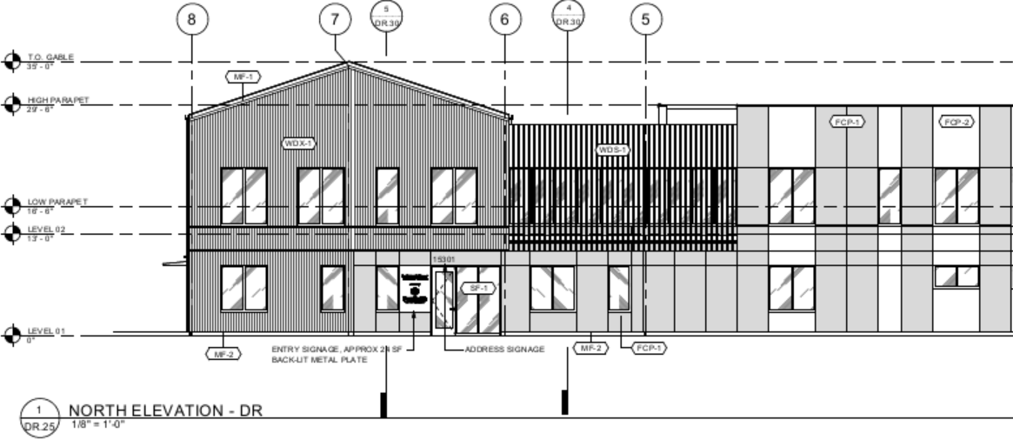
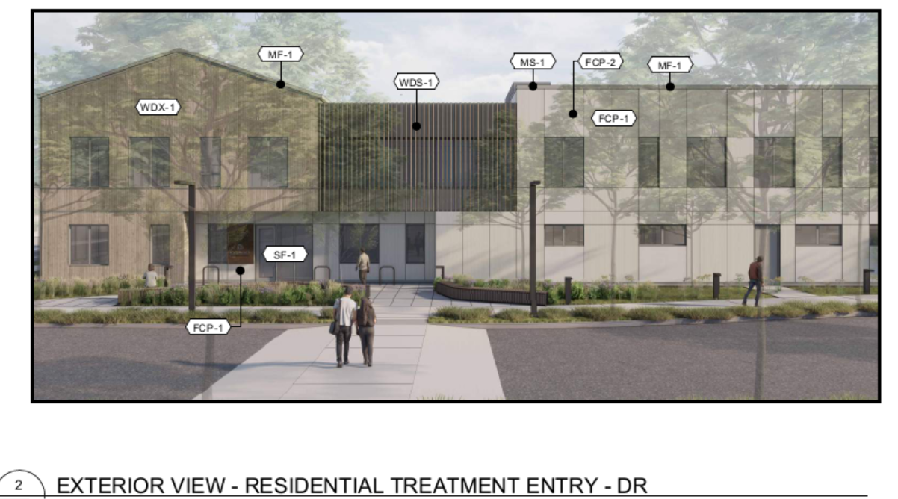
Building 2 has a gable roof with no eaves. The roof vents will be placed opposite SE 92nd Ave.
Since the design does not include eaves on the gable roof of either building, the applicant has requested a design modification pursuant to ZDO Section 1005.06. A modification may only be granted if the proposal will result in a development that achieves the purposes stated in Subsection 1005.01 as well or better than the requirement listed. Staff requested DRC to consider whether the proposed design (i.e. no eaves on a pitched roof along the frontage of SE 92nd Ave) meets or exceeds the purpose of this section; their review concluded that it does.
- 1005.03(E): Requirements for exterior building materials:
- Use architectural style, concepts, colors, materials, and other features that are compatible with the neighborhood’s intended visual identity.
- Building materials shall be durable and consistent with the proposed use of the building, level and exposure to public view, exposure to natural elements, and ease of maintenance.
- Walls shall be surfaced with brick, tile, masonry, stucco, stone or synthetic equivalent, pre-cast masonry, gypsum reinforced fiber concrete, wood lap siding, architecturally treated concrete, glass, wood, metal, or a combination of these materials.
- The surfaces of metal exterior building materials that are subject to rust or corrosion shall be coated to inhibit such rust and corrosion, and the surfaces of metal exterior building materials with rust or corrosion shall be stabilized and coated to inhibit future rust and corrosion.
Finding: The applicant provided the following narrative response:
“Neighboring buildings include several one and two-story single and multi-family homes, a church, and commercial spaces across 92nd Ave. Most roofs are gable-form asphalt-shingle, with one two-story building across 92nd Ave displaying a flat roof. Predominant exterior materials include vinyl and wood siding. The proposed building uses wood siding and an asphalt shingle gable-form roof on the building masses facing 92nd Ave to complement the existing neighborhood architectural style.” The portion of Building 1 internal to the site, with the flat roof, consists of fiber cementitious panel siding.
Staff incorporates the applicant’s findings into the decision. These standards are met.
- 1005.03(G): Requirements to increase safety and surveillance.
Finding: The site lighting is designed to illuminate the campus to enhance the safety and surveillance of the site. Windows are oriented to the street and to the onsite walkways and parking areas. This criterion is met.
- 1005.03(H): Solar access requirements.
Finding: The sleeping rooms on the second floor of Building 1 all face south. This section requires that “overhangs, balconies, or other shading devices” be provided “to prevent excessive summer heat gains” however there are no such features proposed. The written project narrative states that there is an overhang on the second floor patio to provide solar shading, but the patio does not meet the standards of this section. In response to this criteria, information from the applicant submitted on March 17, 2026 states the following:
“All sleeping unit windows will have interior blackout window shades to prevent excessive summer heat gain, this meets the requirement as ‘other shading devices.’ Sleeping unit windows are vertically oriented to help reduce afternoon heat gain. Both buildings have been analyzed via building energy models and improve upon baseline EUI by 31% for building 1 and 37% for building 2. Speciﬁed windows will have U-value of no more than 0.27 and building exterior assembly includes 2” mineral ﬁber board insulation as well as R-21 glass ﬁber batt in the stud cavities, both of which exceed state minimum energy code requirements.”
Since the solar access requirements are, in part, being met by window shades rather than the design features of the building itself (e.g. an overhang), to ensure this criterion is met a condition of approval will be imposed.
The south side of the second floor cantilevers over the first floor which will enhance the solar shading on the first floor in the summer to satisfy this requirement.
Building 2 is not oriented so that the longest building elevation is within 20 degrees of true south and does not maximize the south-facing dimensions as required by section 1005.02(A)(2) and modified by section 1005.06, as discussed above. The main entrance door and window to the vestibule on the southern façade are transparent and are shielded with a 6-foot overhang. To the extent that this standard can be applied to Building 2, it is met.
- 1005.03(I): Requirements for compatibility with the intent of the design type or with the surrounding area. For purposes of Subsection 1005.03(I), design types are Centers, Station Communities or Corridor Streets as identified on Comprehensive Plan Map IV-8, Urban Growth Concept; X-CRC-1, Clackamas Regional Center Area Design Plan, Regional Center, Corridors and Station Community; X-SC-1, Sunnyside Corridor Community Plan, Community Plan Area and Corridor Design Type Location; or X-MC-1, McLoughlin Corridor Design Plan, Design Plan Area.
Finding: This property is not within a design type listed. This criterion is not applicable.
- 1005.03(J): Requirements for screening mechanical equipment.
Finding: The rooftop mechanical equipment for Building 1 will be located on the flat roof and will be shielded from view by the parapet. Rooftop equipment on Building 2 is located in a roof well that will screen the equipment from the public view.
- 1005.03(F, K and L): Are not applicable to this development because the property is within the C-3 zoning district and the proposal is not for multifamily dwellings and middle housing.
1005.04 Outdoor Lighting: Standards for outdoor lighting devices.
Finding: The applicant submitted a photometric plan and associated information on light fixtures. The plans clearly demonstrate that pole-mounted lights will not be mounted higher than 25 feet and that entrance lighting will not exceed a height of 12 feet. As proposed, it is clear that the outdoor lighting will comply with the standards of this section.
1005.05 Additional Requirements Development: shall comply with a minimum of one of the following techniques per 20,000 square feet of site area. Regardless of site size, a minimum of one and a maximum of five techniques are required. Partial site area numbers shall be rounded.
Finding: The proposed development area necessitates the use of five techniques. The applicant proposes to implement the following five techniques:
(A) A solar energy system is proposed to be mounted to the roof of Building 1.
(B) Use deciduous trees to provide summer shade and allow winter sun by planting deciduous trees on south side of site. Deciduous vines will be installed on trellises on Building 2 in the courtyard.
(C) The flat-roof portion of Building 1 will have highly reflective TPO material.
(D) The courtyard for Building 1 is located on the south side of the building.
(H) One additional swale in the parking lot.
1005.06 Modifications: Modification of any standard identified in Subsections 1005.02 and 1005.03 may be approved as part of design review if the proposed modification will result in a development that achieves the purposes stated in Subsection 1005.01 as well or better than the requirement listed.
Section 1005 is adopted to ensure sites are developed and buildings designed to:
- Efficiently utilize the land used in development, particularly urban land in centers, corridors, station communities and employment areas;
- Create lively, safe, attractive and walkable centers, corridors, station communities, employment areas and neighborhoods;
- Support the use of non-auto modes of transportation, especially pedestrian trips to and between developments;
- Support community interaction by creating lively, safe and attractive public use spaces within developments and on the street;
- Reduce impacts of development on natural features and vegetation;
- Utilize opportunities arising from a site’s configuration or natural features;
- Encourage use of green building technologies and green site development practices, energy conservation and use of renewable energy resources;
- Design illumination so that dark skies are maintained to the extent possible, balanced with the lighting needs of safe and functional developments; and
- Accommodate the needs of the users to be located in developments.
Finding: Two modifications are requested:
1) 1005.02(B) which requires that all building elevations be oriented within 20 degrees of true south. The standard is met with Building 1, but not Building 2. For reasons provided earlier in this report, this modification is granted.
2) 1005.03(D) which requires all buildings with pitched roofs to have eaves overhang a minimum of 24 inches. The applicant proposes no eaves. The DRC reviewed the application and recommend approval of the design modification .
6. ZDO Section 1006, Utilities, Street Lights, Water Supply, Sewage Disposal, Surface Water Management, and Erosion Control
1006.02 Street Lights: Street lights are required for all development inside the Portland Metropolitan Urban Growth Boundary.
Finding: The subject property is inside the Portland Metropolitan Urban Growth Boundary; therefore, street lights are required to be installed pursuant to the requirements of Clackamas County Service District No. 5 and the electric company serving the development. The property does not appear to be within the Clackamas County Service District No. 5 and so the property will likely need to annex into the district. Compliance with this section can be met with conditions of approval.
1006.03 Water Supply: Development which has a need for, or will be provided with, public or community water service shall install water service facilities and grant necessary easements pursuant to the requirements of the district or company serving the development. Approval of a development that requires public or community water service shall be granted only if the applicant provides a preliminary statement of feasibility from the water system service provider.
Finding: Clackamas River Water is the water provider in this area. A signed preliminary statement of feasibility was provided by the applicant confirming that water service, including fire flows, is available in levels appropriate for the development and adequate water system capacity is available in source, supply, treatment, transmission, storage, and distribution, or such levels and capacity can be made available through improvements completed by the developer or the system owner. This criterion is met.
1006.04 Sanitary Sewer Service: All development that has a need for sanitary sewers shall install the facilities pursuant to the requirements of the district or company serving the development. Approval of a development that requires sanitary sewer service shall be granted only if the applicant provides a preliminary statement of feasibility from the sanitary sewage treatment service provider and the collection system service provider.
Finding: Clackamas Water Environment Services (WES) is an intergovernmental entity formed pursuant to Oregon Revised Statutes Chapter 190 for the purpose of providing regional sewerage works, including all facilities necessary for collecting, pumping, treating, and disposing of sanitary or storm sewage within its boundaries. WES is the sewer provider in this area. A signed preliminary statement of feasibility was provided by the applicant confirming that sanitary sewer capacity in the wastewater treatment system and the sanitary sewage collection system is available to serve the development or can be made available through improvements completed by the developer or the system owner. This criterion is met.
1006.06 Surface Water Management: Positive drainage and adequate conveyance of surface water shall be provided from roofs, footings, foundations, and other impervious or near-impervious surfaces to an appropriate discharge point. Approval of a development shall be granted only if the applicant provides a preliminary statement of feasibility from the surface water management regulatory authority. The statement shall verify that adequate surface water management, treatment and conveyance is available to serve the development or can be made available through improvements completed by the developer or the system owner.
Finding: Clackamas Water Environment Services (WES) is an intergovernmental entity formed pursuant to Oregon Revised Statutes Chapter 190 for the purpose of providing regional sewerage works, including all facilities necessary for collecting, pumping, treating, and disposing of sanitary or storm sewage within its boundaries. WES is the surface water management authority in this area; a signed preliminary statement of feasibility was provided by the applicant confirming that adequate surface water management, treatment, and conveyance is available to serve the development or can be made available through improvements completed by the developer or the system owner with conditions. This criterion is met.
- ZDO Section 1007, Roads and Connectivity
Section 1007 includes standards for roadways and connections, including bicycle and pedestrian infrastructure.
Finding: The proposed development is subject to the provisions of Clackamas County Zoning and Development Ordinance (ZDO) Section 1007 pertaining to roads and connectivity, Section 1015 pertaining to parking and loading, and Water Environment Services requirements and Roadway Standards Chapter 4 pertaining to surface water management.
The proposed development includes half-street improvements along SE 92nd Ave with additional land use and deferred improvements along SE Tolbert St. All required and proposed improvements along SE 92nd Ave will be required to meet structural section of standard drawing C100 for local roadway serving commercial development and dimensions for urban cross section of standard drawing C110. As proposed, these standards appear to be met.
Both SE Tolbert St and SE 92nd Ave have existing right-of-way width of 33-feet from centerline, which exceeds the minimum requirements of standard drawing C110. No additional dedication is required. The applicant will be required to dedicate an eight-foot wide public sidewalk, sign and utility easement along the entire frontage of SE Tolbert St and SE 92nd Ave.
Street trees are required on the entire frontage of SE 92nd Ave. Species shall be chosen from the County’s approved street tree list. The proposal includes a combination of the American Hornbeam and the Princeton Sentry Ginko which are both on the approved street tree list for planter strips 3.6 feet to 6 feet in width.
- ZDO Section 1009, Landscaping
Section 1009 seeks to ensure that sites are design with appropriately selected, designed, installed, and maintained landscape materials and that landscaped areas are used for appropriate purposes.
Finding: Table 1009-1, Minimum Landscaped Area, establishes the minimum percentage of the area of the subject property that shall be landscaped. In the C-3 zoning district, the minimum landscaped area required is 15%; updated plans submitted on March 17, 2026 demonstrate that the proposed landscaping will equate to 15.61% of the C-3 zoned portion of the site.
1009.03 Surface Parking and Loading Area Landscaping:
Of the 98 vehicle parking spaces provided, 22 spaces are considered perimeter spaces. Therefore, a minimum of 1,900 square feet of landscaping is required. The written narrative states that there is 6,336 square feet of interior parking lot landscaping provided.
The parking lot includes six rows of parking, so a minimum of one landscape swale is required. The swale shall be developed for the entire length of the longest row of parking spaces. The narrative states that the two interior rows of parking will be developed as a landscaped swale. Each swale is at least 4 feet in width.
The width of the interior landscaped areas meets the minimum standard of four feet. There is a minimum of one tree for every eight interior parking spaces. There are no perimeter parking spaces that are adjacent to abutting lots or the right-of-way; however, the proposed loading area for Building 1 is adjacent to the right-of-way. A landscaping strip a minimum of five feet wide is proposed adjacent to the perimeter of the loading/turning area.
1009.04 Screening and Buffering:
The parking lot, loading area and receptacles for solid waste or recyclable materials are proposed to be screened from the abutting residential properties. Buffering techniques are required along the southern property boundary due to the dissimilar adjoining uses (commercial/residential). The applicant states that a 7-foot tall sight obscuring fence will be provided near the southern property boundary. The written project narrative states that “the fenceline sits within a 5-foot landscaped buffer that includes numerous existing established trees and shrubs which are to be preserved”. ZDO Subsection 1009.04(E) provides four ways to comply with Buffering; the applicant has requested review of 1009.04(E)(3). Updated plan materials submitted March 17, 2026 also included arborist report, tree protection plans, and existing conditions photos of the existing vegetative buffer along the southern property line.
The arborist report, dated June 16, 2025, describes in general terms the vegetation along the southern property boundary as including English laurel, Norway maple, and English holly, all of which are considered nuisance species within the region, according to the arborist’s report. ZDO Section 1002.02 defines “nuisance tree” and includes English holly and English laurel, but does not include the Norway maple.
In an email from the applicant on March 24, 2026, the applicant notes that according to the Clackamas Soil and Water Conservation District’s website, these species are not identified on their “noxious weed list.” Upon further review of the Conservation District’s website and additional resources, English holly is identified a not noxious but invasive, explaining why it does not appear on the noxious weed list referenced by the applicant. Pursuant to Section 1009.01(C) existing invasive non-native or noxious vegetation shall be removed; therefore, the English holly shall be removed.
In an email on March 24, 2026 the applicant provided further information from the project landscape architect related to the extent to which the visual screening with the existing vegetation will be maintained and to what extent the identified “nuisance” species will be retained, if any, or how the landscape may change with the construction.
“All the trees other than #2440 and #2441 are proposed to be retained along the south property line - unfortunately trees 1 through 6 in this area are outbound of the existing fence and were not inventoried by the arborist. As such, specific information about them - other than their location - was previously omitted from the plans. We have some information from the survey, which we have added to the tree plans for clarity. I cannot confirm if the information about them from the surveyor was verified by an ISA board certified arborist. Keynote 5 is intended to indicate that the arborist should field verify and advise if proposed work near these trees requires performance path preservation or a standard approach - the intent was not for them to be removed. Regardless, oversight of work within their rootzones is required by keynote 4.
The existing hedgerow and many of the trees span the property line. Existing non-native and noxious plants on site will be removed per note 04 on the planting schedule and notes sheet and keynote 05 on the materials sheets in accordance with 1009.01.C.. Much of the existing screening, particularly above the height of our proposed fence, is provided by the trees, which appear to be primarily big leaf maples along the south property line nearest to our development area. The Norway Maples are largely clustered near the Southwest corner and west property line, quite a distance from our proposed development area. This gradient of species transition can be teased out of the inventory by comparing the numbers to species moving eastward - I've added a snip below demonstrating this distribution, with blue dots indicating Norway Maples and green indicating Big Leaf Maples.”
Based on the written descriptions, submitted arborist report, tree removal and preservation plan, distribution and density of English holly and photos submitted for consideration, it remains uncertain whether existing vegetation will sufficiently buffers the proposed use from the residential neighbors to the south. As such, a condition of approval is warranted to ensure that buffering standards are met. Although there are many ways in which buffering can be met, the method that most closely aligns with the applicant’s existing proposal is subsection item number 3, which includes a landscaping strip a minimum of five feet in width along the southern property boundary that includes the following three items:
          - A masonry wall or sight-obscuring fence a minimum of six feet in height. The wall or fence is to be placed along the interior side of the landscaping strip;
          - Evergreen vines, evergreen trees, or evergreen shrubs, any of which shall be spaced not more than five feet apart; and
          - Low-growing evergreen shrubs and evergreen ground cover covering the balance of the area.
Buffering requirements were discussed at the DRC meeting on February 27, 2026 as they relate to the impacts the proposed generator will have on the residential properties to the south. In response, the applicant submitted an acoustic analysis dated January 28, 2026 that recommends a sound barrier constructed of two layers of 3/4-inch plywood on a wood frame, if no holes or gaps are found within the barrier. At the time the applicant resubmitted their application materials, March 17, 2026, no specific sound barrier has been proposed but they acknowledge they are working to identify their specific proposal. An email sent March 24, 2026 indicates that the applicant will propose a barrier that “will look like the rest of the fence from the exterior, with (2) layers of 3/4" plywood on the interior, and a cap for weather protection.” A condition of approval is warranted to ensure that this barrier is installed and that the buffering requirement for noise attenuation of the generator is met.
- ZDO Section 1010, Signs
Subsection 1010.09 provides standards for signs in commercial districts.
Finding: Only one freestanding sign for a development or complex is permitted; the applicants propose only one freestanding sign. The sign will be a two-sided monument sign, 27 square feet in area, and will be three feet tall. The sign will be located at the driveway entrance north of Building 1. The exception to the one-sign rule, pursuant to Section 1010.09(A)(1)(e) which states “In the C-3 and RTL Districts, one additional freestanding sign may be allowed on a public, county, or state road when the frontage on that road exceeds 450 feet” is not applicable to this subject property because the C-3 zoned portion of the property frontage is less than 450 feet in length. The monument sign is located behind the property line, which complies with this section. The monument sign is not proposed to be lit internally; the lighting plan shows there will be a bollard light on either side of the sign.
Subsection 1010.02(I) provides the standards for externally illuminated signs. The light must be placed, shielded, or deflected so they do not shine into dwellings or impair the vision of the driver of any vehicle. Based on the submitted lighting plan and bollard light fixture chosen, it is expected that the proposal will comply with this section.
Since there will be a monument sign on the SE 92nd Ave frontage, the maximum size of a building sign is the equivalent to one square foot of sign area per linear footage of the occupant’s primary building wall. As proposed, Building 1 is 84 feet and 10 inches in length. Building 2 is 168 feet and 11 inches in length. Building 1 is authorized to have up to 84 square feet of signage. Building 2 is authorized to have up to 168 square feet of signage.
On Building 1, the east façade (facing 92nd Ave) is the primary building wall. The applicant does not propose to have signage on the street-facing façade, but instead proposes to have two 24 square foot building signs to be located on the northern façade (the secondary building wall). On Building 2, the east façade is the primary building wall. The applicant proposes to have one 24 square foot building sign on the east façade and a second building sign, this one of 60 square feet, on the southern façade (the secondary building wall).
Per Section 1010.09(B)(2), wall signs based on the sign rights of a primary building wall may be placed on a secondary building wall, but they may not be placed onto another primary building wall. ZDO Section 202 defines “primary building wall” as the “exterior building wall which contains a public entrance to the occupant’s premises and faces either a street or a parking area.” The vehicular access onto the subject property located between Building 1 and Building 2 is not a street or a parking area and therefore is not considered a primary building wall for the purposes of this section.
As proposed, the application complies with the standards of this section.
- ZDO Section 1015, Parking
Section 1015 is designed to ensure that developments in Clackamas County provide sufficient and properly designed parking for motor vehicles and bicycles as well as appropriate off-street loading areas.
Finding: The Climate Friendly and Equitable Communities (CFEC) rules are in effect pursuant to OAR 660, Division 12. Per OAR 660-012-0400 through OAR 660-012-0450, a minimum number of off-street vehicular parking spaces cannot be required for any development that is within the Urban Growth Boundary and is served by an urban water and sanitary service. This property is eligible to follow the CFEC rules; therefore, no minimum vehicle parking is required. However, since the applicant is electing to provide new vehicle parking spaces, the standards of this subsection apply.
Vehicle parking maximums apply pursuant to OAR 660-012-0415 which limits parking to five spaces per 1,000 square feet of floor area of all commercial and retail uses. However, there is no limit to the number of parking spaces provided for residential uses. Since this is a mixed-use development with a shared/common parking lot for all uses, there is no reasonable way for staff to implement the maximum parking rule. Therefore, maximum parking will not be reviewed.
Parking areas are hard-surfaced with either concrete or asphalt shown on Materials plans DR.13-15. 52 of the 98 vehicle parking spaces provided, or 53%, are no larger than 8.5 feet by 16 feet. Double-loaded, 90 degree angle parking bays are provided wherever possible. The applicant will be required to provide written approval for Clackamas Fire for access, maneuverability and fire suppression. All parking areas shall meet minimum requirements of Roadway Standard Drawing P100/P200 for dimensions. The applicant will be required to provide an approvable onsite striping and signage plan.
Carpool/vanpool parking spaces are not required, since there is no minimum “required” vehicle parking. The applicant is choosing to provide these parking spaces, and they will be identified with paint.
section 320.3 of the Clackamas County Roadway Standards requires non-passenger designed vehicles to provide an exhibit displaying onsite maneuvering with wheel paths traced to ensure ingress and egress in a forward motion. The applicant resubmitted plans on March 17, 2026 relocating the trash enclosure for Building 1 to the southwestern corner of the parking lot and expanding the loading zone for Building 1. Within the revised plan set is an exhibit showing the wheel path for loading zone for Building 1. The trash enclosure relocation and loading zone expansion will allow full onsite circulation of non-passenger vehicles which complies with the standard.
Bicycle Parking:
The minimum number of bicycle parking spaces listed in Table 1015-3, Minimum Required Bicycle Parking Spaces, are required. The uses not specifically listed the ZDO requires us to apply the requirements for the most similar use.
Proposed Use | Use Listed in Table 1015-3 | Number of Spaces Required
Treatment Facility (40 beds)  (Building 1) | “Residential Care Facilities, Nursing Homes, and Hospitals (per 8 beds)” | 5 spaces
Outpatient Clinic and Offices/Admin  (Building 2) | “Retail and Commercial including offices and clinics” (1 per 2,500 square feet) | 3 spaces
Transitional Housing/Single Room Occupancy (20 rooms)  (Building 2) | Multifamily Dwellings (per dwelling unit) | 10 spaces
Single Room Occupancy (SRO) is not listed in Table 1015-3, but is most similar to multifamily dwellings which have a bike parking requirement of 0.5 space per dwelling unit. In the case of SROs, the application of the standard would be 0.5 spaces per room.
The bicycle parking plan is shown on Sheet DR.05. The scope of this project will include a total of 20 bicycle parking spaces for both buildings. The bike rack detail is shown on Detail 06, Sheet L8.10, and demonstrates that the rack meets the standards of this section
Subsection 1015.03(A) states that at least 75% of the required bicycle spaces must be within 50 feet of a public entrance. 14 spaces are located within 50 feet of either public entrance. At least 50% of the required bicycle spaces must be covered. The applicant proposes to have 12 covered and eight uncovered spaces. These standards are met.
Loading:
The minimum loading berth requirements are specified in ZDO Section 1015, Table 1015-4. which meet the minimum required dimensions of 35 feet x 12 feet x 14 feet high. There are two proposed loading areas. One on the south side of Building 1 with direct access onto SE 92nd Ave. and the other is on the north side of Building 2 near the trash enclosure.
The standards of Section 1015 are met as proposed.
- ZDO Section 1021, Soil Waste and Recyclable Material Collection
Section 1021 applies to multifamily dwellings, and institutional, commercial, and industrial developments. It provides standards for the design, placement, and accessibility of trash enclosures.
Finding: The land use application was forwarded to the County’s Sustainability and Solid Waste division for their review. Their comments from their review of the updated plan set submitted March 17, 2026 are incorporated below.
The applicant proposed two trash enclosures. One on the southwest corner of the parking lot and another on the north side of the northern building, “Building 2”. Each enclosure will be on a concrete pad and will be made of cedar fencing.
Enclosure for Building 2 is surrounded by a 7-foot tall cedar fence and includes a bumper curb. There is a partition wall in the enclosure to separate the bicycle parking from the solid waste and recycling area. The bumper curb proposed appears to be 6-inches wide; however, the minimum requirement of this Section is only a two- to four-inch curb. The larger 6-inch curb is still acceptable.
Both enclosures are approximately 12’2” D x 21’5” W x 7’ H and made of western cedar slats with an approximate 12-foot wide gate opening and set on a 6-inch concrete pad with drain. The service gates have cane bolts, and “No Parking” signage is posted on the exterior of the enclosure.
As proposed, these standards are met.
- ZDO Section 1102, Design Review
Section 1102 is adopted to provide standards, criteria, and procedures under which design review may be approved.
1102.01 Purpose and Applicability: Design review is required for development, redevelopment, expansions, and improvements in Commercial zoning districts.
Finding: The subject property is located in the General Commercial (C-3) zoning district which is a commercial zoning district. A Design Review land use application is required. The applicants have successfully applied for a Design Review land use application. This standard is met.
1102.02 Submittal Requirements: Design review submittal requirements are established.
Finding: Clackamas County Planning and Zoning reviewed the submitted land use application for completeness to ensure that all required items were turned in with the application. This criterion is met.
1102.03 Approval Criteria: Design review requires review as a Type II application pursuant to Section 1307, Procedures, and shall be subject to the following standards and criteria.
Finding: A complete review of all applicable standards in Section 1000 will be provided prior to issuance of a final decision.
1102.04 Design Review Committee: A Design Review Committee (DRC) shall be established pursuant to Subsection 1307.03 and shall have the responsibilities assigned to it by Subsection 1102.04.
Finding: Due to the size of the project, including mass of buildings, site area, landscaping, and parking requirements, visual significance, and the potential impact on neighboring properties and adjacent residential area County Planning staff determined that it was necessary to forward the application to the DRC for review.

ADVISORY NOTES
Advisory notes are not a part of the decision on this land use permit. The items listed below are not conditions of land use approval and are not subject to appeal. They are advisory and informational only but may represent requirements of other agencies/departments. As such, they may be required by these other agencies/departments in order to complete your proposed development.
1. Clackamas Fire District #1, Valere Liljefelt, Deputy Fire Marshal:
It has been determined that this property is in an area with public water supply, and there are no site conditions that would prevent the applicant from constructing the proper access. Fire department access and water supply are reviewed in accordance with the 2022 edition of the Oregon Fire Code (OFC).
Submit Fire access/water supply site plan via CFD1 website Fire access/water supply submittal link. Fire Access and Water Supply Plan Submittal - Clackamas Fire District (linked) The Fire code application guide link is on the instructions page.
For design assistance we provide additional information with the Fire Code Application Guide found on the first page of the submittal process.
When submitting plans for fire department access and water supply approval please include the following information:
- Fire apparatus access
- Fire lanes
- Fire hydrants
- Fire lines
- Available fire flow
- FDC location & riser room (if applicable)
- Fire suppression vault (if applicable)
- Power lines crossing access lanes
- Building square footage
- Construction type
- Fire flow test per NFPA 291 no older than 12 months

